# 

# **Assessment**

# **Ansible 2**

Trainee Name : Aditya Upadhyay

Newers ID : 3978

Mentor Name : Tarun Saxena

College : UPES

**1. Create two nodes with tag:key role and tag:value master & slave respectively. Setup the dynamic inventory on ansible control nodes.**

**Run the following modules using tag key-value:**

**1.1 Ping master node and slave node separately.**

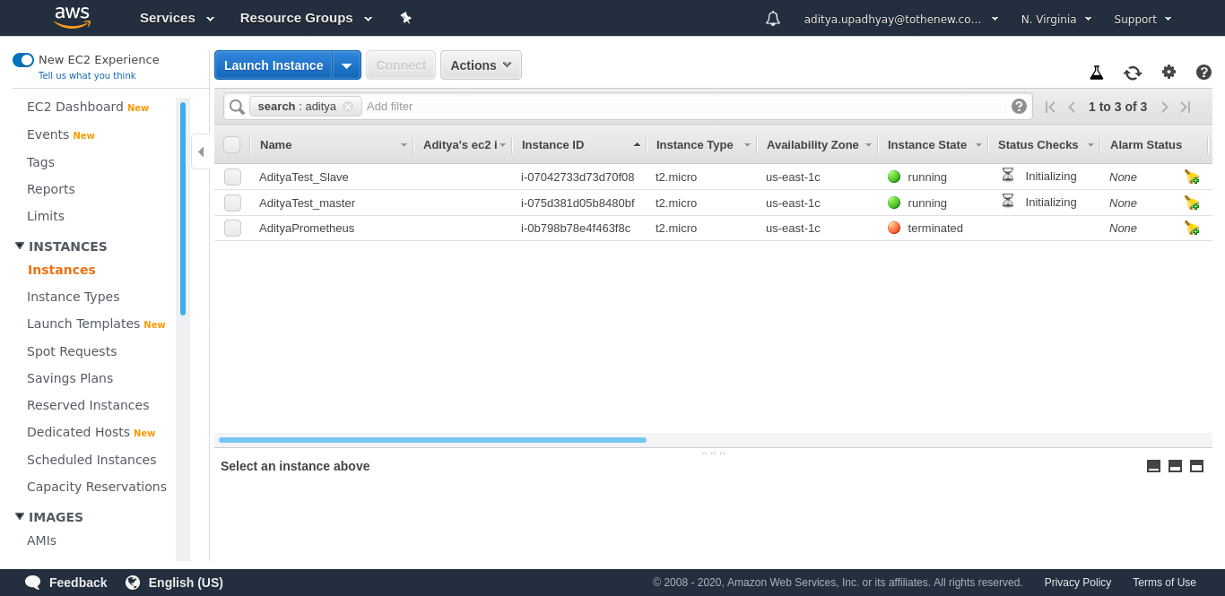

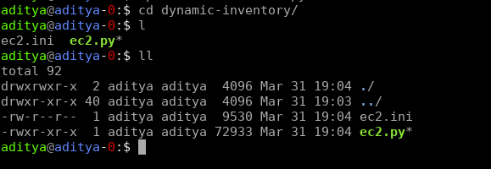

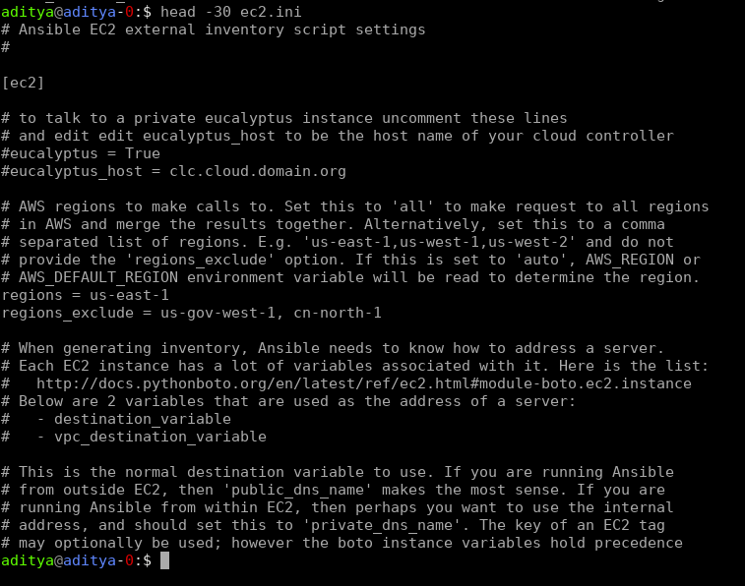



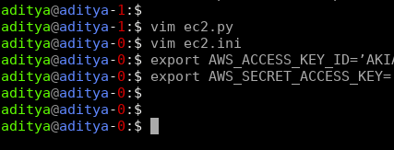

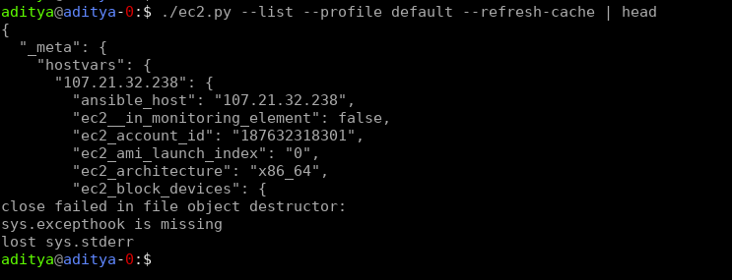

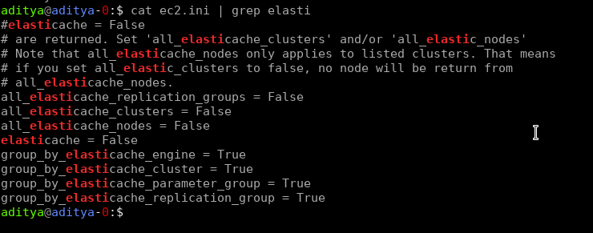

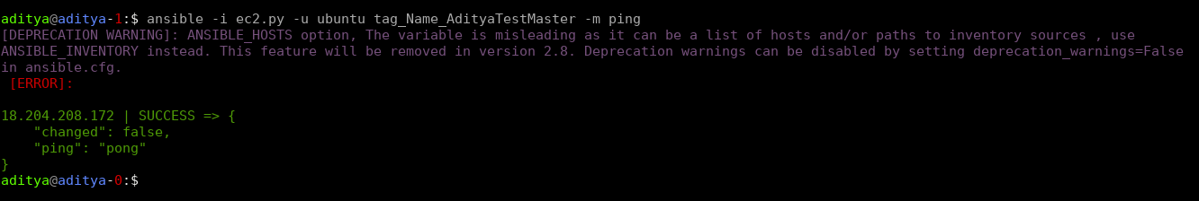

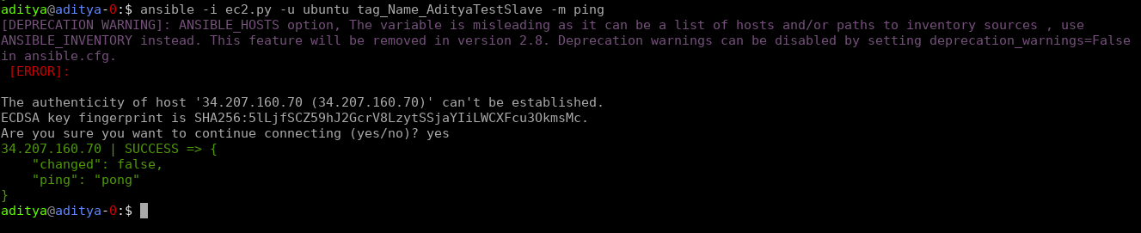

Ref: https://devopsmates.com/ansible-dynamic-inventory-for-aws-ec2/

**1.2 To check all running processes on slave node.**

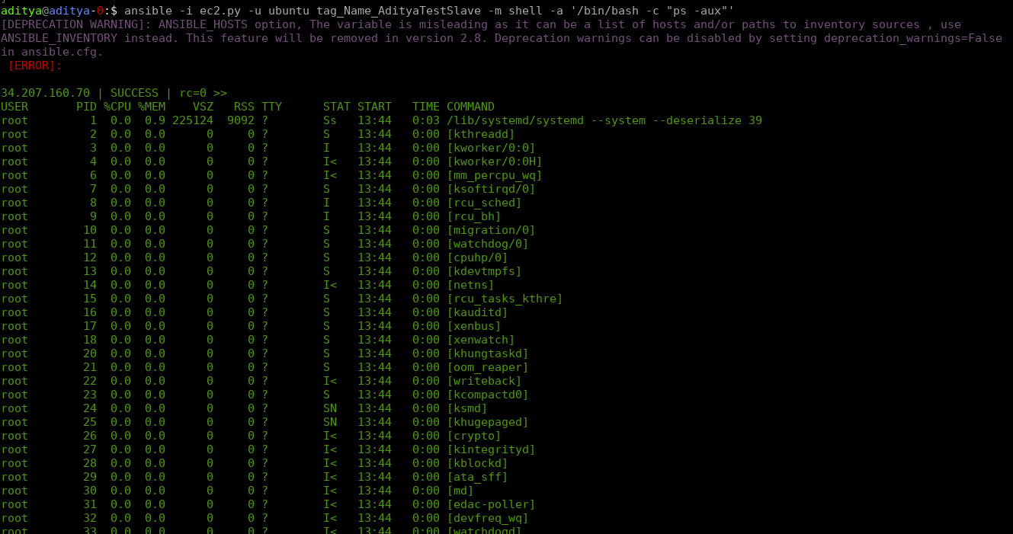

**1.3 To copying files to both nodes concurrently.**

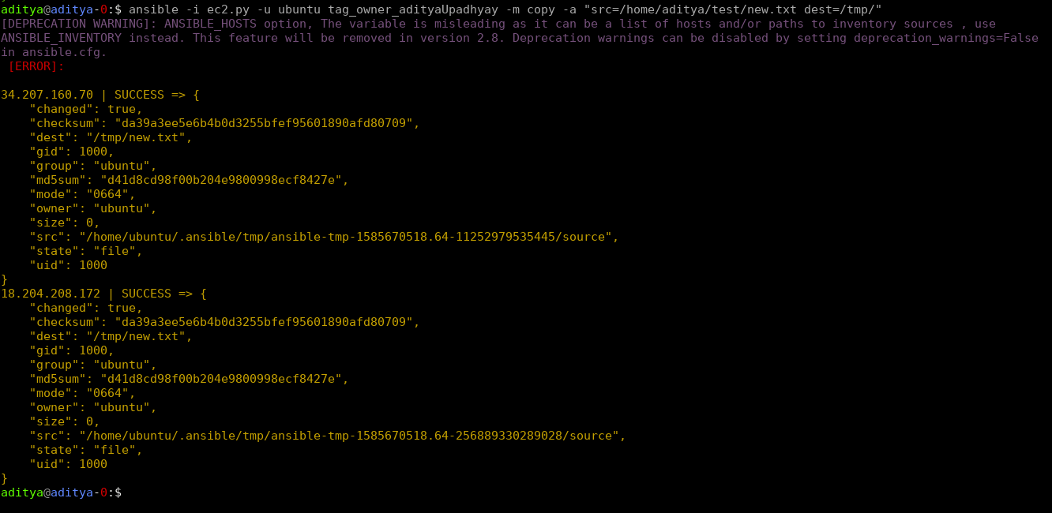

**2. Setup nginx on both nodes with a single custom configuration template, on master nginx should run on 8000 while on slave nginx would listen on port 80. [Jinja2+conditional]**

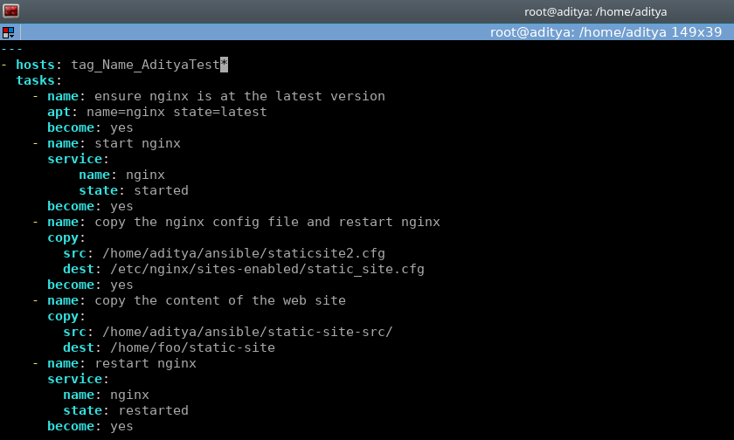

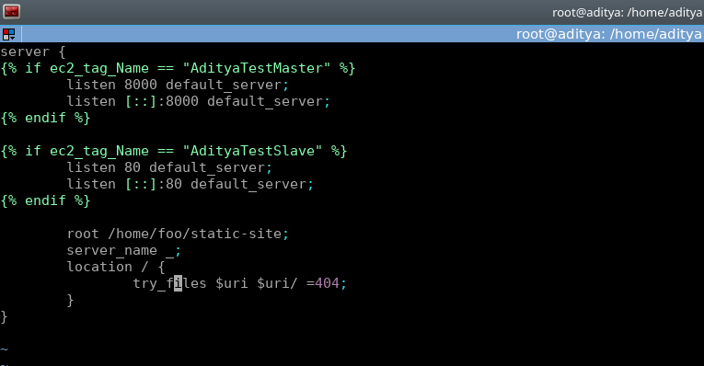

**Q3. Setup mysql on a remote server, create a user with password. Passwords should be encrypted using Ansible vault. Verify the setup by log in to mysql.**

